**How to check status of Renaissance Diagnostics- Prospect K Dual**

****Follow the directions below to check which students completed the diagnostic.

1.Log in to your Renaissance account.

1. Click on the reports tab (click on star/assessment)

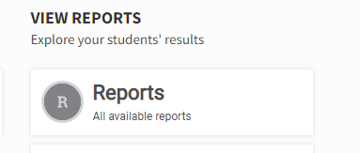

1. Scroll down until you see test status and results.

Click on start test activity report

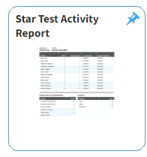

1. Select the assessment and then press update report. (check for all 4 assessments- star early literacy english/spanish and star math english/spanish)

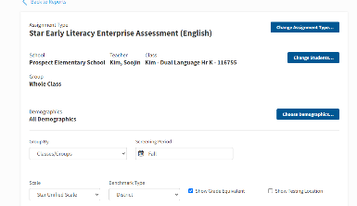

There will be an area that tells you which students completed this particular test and which students did not.